HTML & CSS

HTML:

raw data a webpage is build out of, how docs and web pages are displayed

CSS:

adds style to those plain elements, colours, fonts, positions

JavaScript:

Allows changes to HTML & CSS element after the website has been loaded

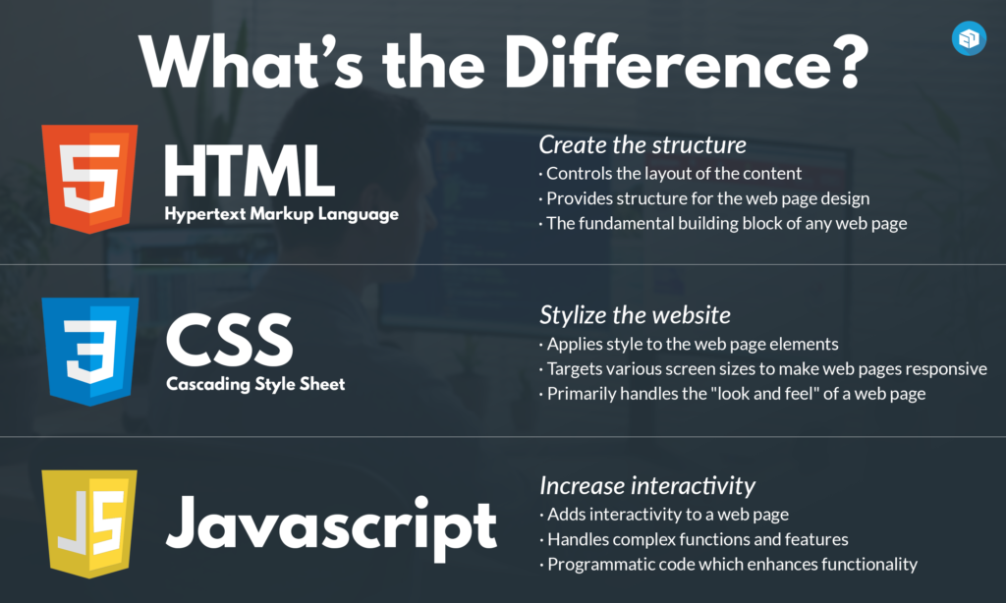

HTML (HyperText Markup Language):

Elements & Tags:

**Elements** are pieces of content wrapped in opening & closing HTML **tags**

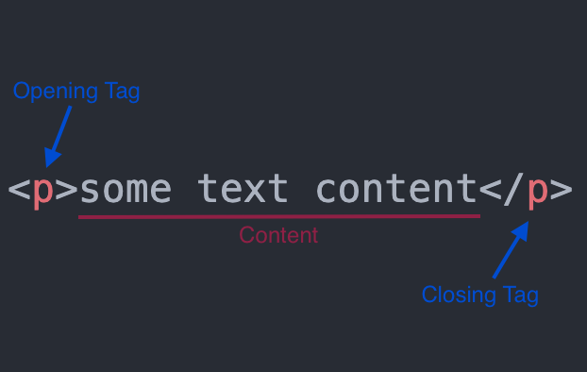

some tags are self-closing tags, e.g. <br />, <img /> do not have a closing tag

All HTML documents have the same basic structure or boilerplate to be in place

**Homepage** is always named **index.html**

Doctype tells the browser what version of HTML it should uses to render the doc.

Latest version of HTML is HTML5, doctype: **<!DOCTYPE html>**

**<html lang="en">** specifies the language of the text content in the element

**<head>** where we put important meta-info, do not use any element that display contect

**<meta charset="utf-8">** should always be added in the <head> for the charset encoding

**<title>My First Webpage</title>** should also alwasys be added in the <head>, which displays in the webpage’s brower tab, if not specified, it would default to its file name (e.g. index.htm).

Example:

<!DOCTYPE html>

<html lang="en">

    <head>

        <meta charset="UTF-8">

        <title>123</title>

    </head>

    <body>

        <h1>Hello Wolrd!</h1>

    </body>

</html>

**<p> </p>** new paragraph

**<h1> </h1>** headings, from h1 to h6, h1 is the most important

**<strong> </strong>** bold and mark text as **important**

**<em> </em>** *italic*

Nesting – indent an element within other element, child within parent

**<!-- -->** comment, not visible to the broswer

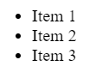**<ul>** |

**<li> x1 </li>** |

**<li> x2 </li>** |

**</ul>** |} unordered list

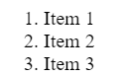**<ol>** |

**<li> x1 </li>** |

**<li> x2 </li>** |

**</ol>** |} ordered list